Faculty and First-Generation College Students: Bridging the Classroom Gap Together
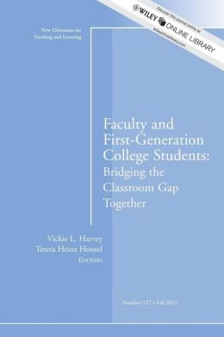
This learning community, co-sponsored by the Office of Diversity, Engagement and Inclusion and the Center for Excellence in Teaching and Learning (CETL), will provide an opportunity for faculty participants to explore intersections of pedagogical issues with intellectual and social context of first-generation students which will ultimately enhance the learning experience for all students.

This learning community will meet in a series of regular 1 ½ hour sessions throughout the academic semester (and maybe into the next semester). Common readings will serve to inform the conversations as we work toward continuing the on-going work of supporting and encouraging student success by addressing the following questions:

- What does a first gen student experience in the classroom, on the Regis campus, at home, and in their community and how do these factors affect student learning?
- How does teaching students "on the margin" affect teaching students who are "in the middle?"
- What promising practices have proven effective teaching strategies for first-generation students?

Common readings:
- “First Generation Latina Graduate Students: Balancing Professional Identity Development with Traditional Family Roles” by Valerie Leyva
- “A Social Constructivist View of Issues Confronting First-Generation College Students” by Stephen Coffman
- “Critical Compassionate Pedagogy and the Teacher's Role in First-Generation Student Success” by Richie Hao Havery, V.L. and Housel, T.H. (2011).
- Faculty and First-Generation College Students: Bridging the Classroom Gap Together. New Directions for Teaching and Learning, Fall 2012. no. 127.

If you are interested in signing up to be a part of this faculty learning community, please contact Ken Sagendorf in the CETL at ksagendorf@regis.edu or by calling 303-964-6469 or Sandra Mitchell in the Office of Diversity, Engagement and Inclusion at smitchel@regis.edu or by calling 303-964-5304.

